Q1. Create two groups(editor and author) and create users of each group.
Go to useradmin console
Go to Edit->Create->Create Group
Go to Edit->Create->Create User

AUTHOR

(group with having permissions od administrator)

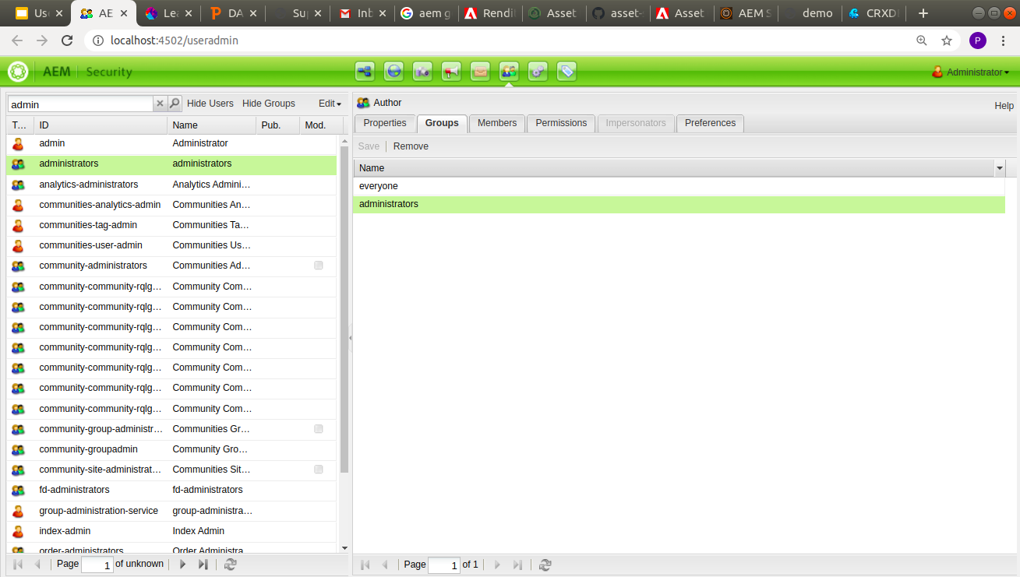
(author user named (joey) from group author)

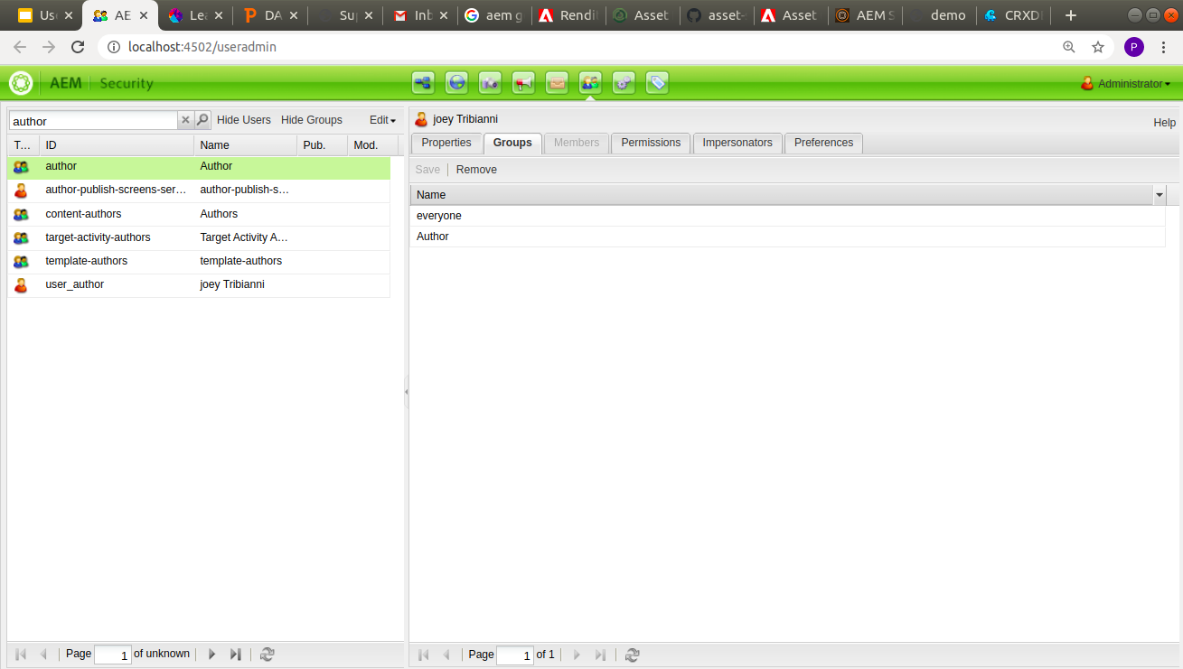
EDITOR

(editor group with some permissions)

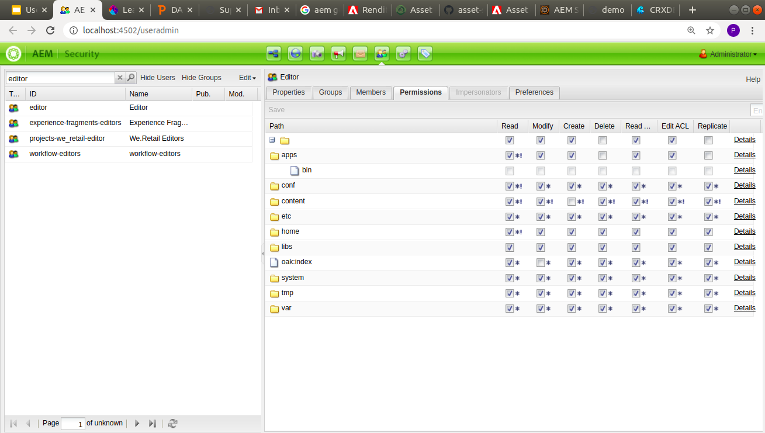

(user named priyanka singh using group editor)

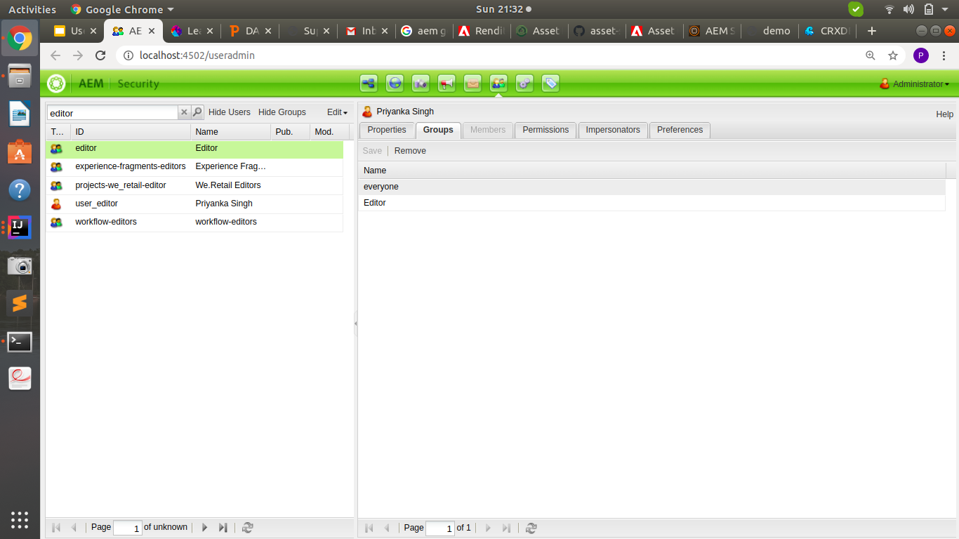
Q2. Impersonate a user of editor gp to author gp and test if you can replicate or delete the pages.
Note: Editor would not have delete and replicate rights
Author would have all rights like administrators
Provide screenshots for questions

Go to useradmin console and search for the user you want to impersonate.
Select that user and go to impersonate tab for that user.
Now, search user to which you want to impersonate and drag that user inside impersonate tab and click save.
(user author impersonates the user editor )
